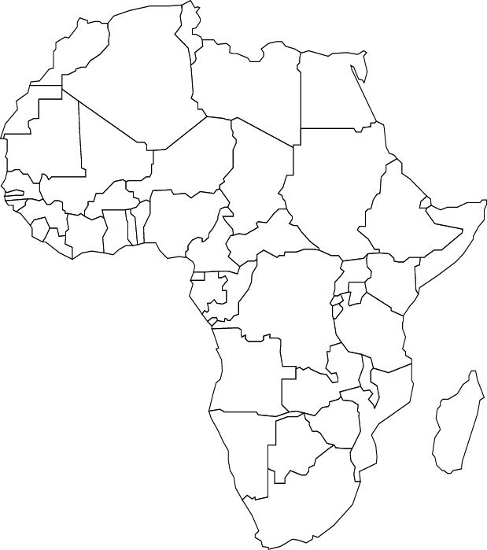

**Africa Ethnic Groups Map**

Directions: Shade in each region where the following ethnic groups reside:

* Ashanti, Bantu, Arab and Swahili

Create a map key

Write a brief description of each ethnic group and explain how their location influences their culture.

Use Coach Book pages 32-33