Africa Study Guide – DUE May 21
Name______________________________________
Label the following on the map below:
1. Sahara
2. Sahel
3. Congo River
4. Nile River
5. Atlas Mountains
6. Kalahari Desert
7. Egypt
8. Nigeria
9. Kenya
10. South Africa
11. Democratic Republic of the Congo

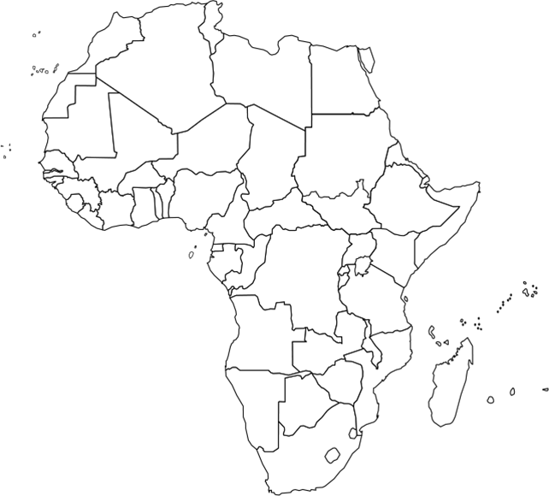

12. Define desertification

13. Describe the Sahara Desert

14. Describe the Sahel

15. Describe the Savanna

16. Describe three environmental isssues in Africa and their impact/effect

17. How does a tribe’s region/location influence its culture?

18. Describe three challenges tribes face when crossing the desert

19. Name the four ethnic groups we studied and provide a very brief description of each.

20. Define imperialism

21. What was the Berlin Conference? How did it lead to Africa’s colonization?

22. What were the two main European countries that colonized Africa?

23. What have all the maps we studied told you about European imperialism during the early part of the 20th century?

24. What is apartheid? Why was it significant?

25. Who was Nelson Mandela?

26. Briefly compare/contrast apartheid to a similar event in history.

27. Explain how nationalism led to independence in South Africa, Kenya and Nigeria

28. Explain how AIDS and famine have impacted Africa.

29. Describe the types of government in Kenya, Sudan and South Africa.

Note: You will also need to study, read and analyze maps similar to the ones we looked at in the Scramble for Africa activity

