Unit 4 Study Guide | China
Test Tuesday March 17, 2014 (DUE Tuesday)

Label the following on the map below:
China, India, Taklimakan Desert, Gobi Desert, Yellow River, Yangtze River
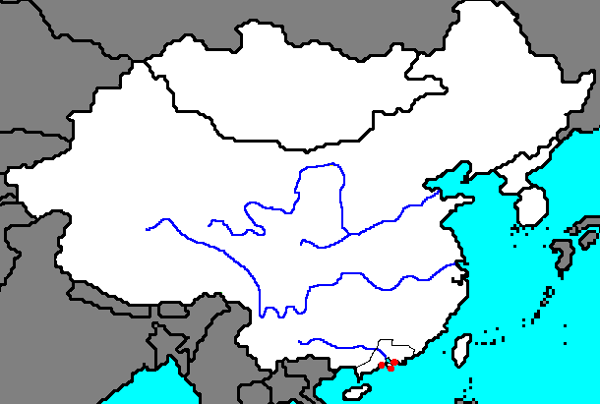

Define the following terms:

Brown cloud (CRCT Book pp. 137 & 140)

Monsoon (CRCT Book pp. 137 & 140)

Describe at least three major environmental issues in China and explain how they have impacted its people. (CRCT Book p. 138 & Environmental Issues Chart)

Explain the significance of China’s Three Gorges Dam and describe at least one pro and one con of the project. (CRCT Book p. 136)

Who was Mao Zedong? Why was he significant? (CRCT Book pp. 196-197 & Notes)

Explain the concept of communism. What is the difference between a “pure” communist society vs. what actually happens in reality (BrainPop video – login myboe pass: brainpop)

Describe the divide between the Chinese Communist Party and the Nationalist Republic of China. (CRCT Book p. 196)

What was the Long March? (CRCT Book p. 197 and Notes)

What was the significance of the year 1949 in China? (CRCT Book p. 197 and notes)

Explain the Great Leap Forward (CRCT Book p. 197 and notes)

Explain the Cultural Revolution (CRCT Book p. 197 and notes)

Describe the events leading up to the Tiananmen Square Massacre. When did it take place? Who was the communist leader at the time? What were students protesting and why? Who was the Tank Man? Why is he significant? (CRCT Book p. 197)

Explain how the events of Tiananmen Square violated human rights. (http://www.un.org/en/documents/udhr/)

Explain how China’s government used censorship to keep the events of Tiananmen Square out of the public eye. Why would they do this?

What kind of government does China have? Explain why. (CRCT p. 162-163)

What type of economy does China have today? How has their economy changed since the Communist Revolution? (p. 162 + p. 169-170).

What are the five primary religions in Asia? (p. 147 Coach Book)

Explain the general concepts of Confucianism. Why is it a philosophy and not a religion? Make sure to include the Golden Rule. (CRCT pp. 148-149)

Explain the general concept of Shintoism. What is a kami? Where did Shintoism begin? (CRCT p. 148)

Japan
Explain the role of the United States in the rebuilding of Japan after World War II using the following terms. (Douglas MacArthur, Diet, Hiroshima, Nagasaki, reparations, Bill of Rights, Constitutional Monarchy) CRCT Book p. 195

Red Scarf Girl – be prepared to answer questions related to the ENTIRE book. You may take a book home if you need to finish reading.

Who was Ji-Li Jiang?

What was the Cultural Revolution? Why did it begin?

Who was Mao Zedong?

Who were the Red Guards? What did they do?

What are “Four Olds?” Provide at least ONE example of something that is Four Olds (based on the book)

What was a dai-zi-bao? How was it used to promote Mao Zedong’s ideas/message and the Cultural Revolution?

What is propaganda? What was the propaganda wall? How did propaganda reinforce Mao Zedong’s ideas during the Cultural Revolution?

What was the little red book?

Who are the proletariat? Who are the bourgeois?

Who was Song Po-Po? How did she contribute to Ji-Li’s family being “bourgeois”?

Humiliation was a theme in the book. How was humiliation used as a tactic during the Cultural Revolution to keep people in line with Mao’s beliefs?

Why is Ji-Li Jiang’s family considered to be part of the Five Black Categories?

What happened to her family as a result of being part of the Five Black Categories?

Why didn’t Ji-Li Jiang hate Mao, even after all her family experienced? (read the epilogue to answer this)

