Unit 4 Study Guide | China
Test Friday March 14, 2014

Label the following on the map below:
China, India, Taklimakan Desert, Gobi Desert, Yellow River, Yangtze River
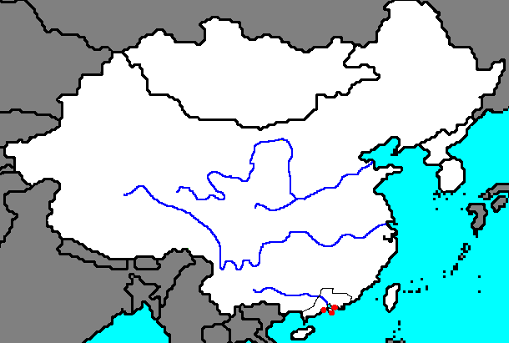

Define the following terms:

Brown cloud

Monsoon

Describe at least three major environmental issues in China and explain how they have impacted its people.

Explain the significance of China’s Three Gorges Dam and describe at least one pro and one con of the project.

Who was Mao Zedong? Why was he significant?

Explain the concept of communism. What is the difference between a “pure” communist society vs. what actually happens in reality (BrainPop video – login learn4life pass: learningbygrace)

Describe the divide between the Chinese Communist Party and the Nationalist Republic of China.

What was the Long March?

What was the significance of the year 1949 in China?

Explain the Great Leap Forward

Explain the Cultural Revolution

Describe the events leading up to the Tiananmen Square Massacre. When did it take place? Who was the communist leader at the time? What were students protesting and why? Who was the Tank Man? Why is he significant?

Explain how the events of Tiananmen Square violated human rights. (http://www.un.org/en/documents/udhr/)

Explain how China’s government used censorship to keep the events of Tiananmen Square out of the public eye. Why would they do this?

What kind of government does China have? Explain why. (

What type of economy does China have today? How has their economy changed since the Communist Revolution? (p. 162 + p. 169-170).

What are the five primary religions in Asia? (p. 147 Coach Book)

Explain the general concepts of Confucianism. Why is it a philosophy and not a religion? Make sure to include the Golden Rule.

Explain the general concept of Shintoism. What is a kami? Where did Shintoism begin?

You will be required to write a summary of Red Scarf Girl. Your summary needs to show that you have read the ENTIRE book. In your summary, you must answer the following:

1. Who was Ji-Li Jiang?
2. What was the Cultural Revolution? Why did it begin?
3. Who was Mao Zedong?
4. What are “Four Olds?” Provide at least ONE example of something that is Four Olds (based on the book)
5. What was a dai-zi-bao? How was it used to promote Mao Zedong’s ideas/message and the Cultural Revolution?

6. What does it mean to be from “Black Family?” Why is Ji-Li Jiang’s family considered to be part of the Five Black Categories?
7. What happened to her family as a result of being part of the Five Black Categories?
8. Why didn’t Ji-Li Jiang hate Mao, even after all her family experienced? (read the epilogue to answer this)

