Red Green Yellow Blue Name___________________________
Date____________________________
Eastern Hemisphere Final Exam
Study Guide
Define quota. (CRCT Book pp. 112-113)
A way of limiting foreign goods that can come into a country
Define embargo.
When a country announces it will no longer trade with another country to isolate the country and cause problems with that country’s economy
Define OPEC.
Organization of Petroleum Exporting Countries; regulate the supply and price of the oil they export to other countries
What will happen to the price of oil if OPEC increases the production of oil?
The price on the world market goes down
Define exchange rate. Why is this system important for nations? (p. 112)
A system of changing from one type of currency to another; for trade
Define capital goods.
the factories, machines and technology that people use to make other goods
List capital goods for Israel and Saudi Arabia. ( p.115)
Israel: Technology, industrial production and advanced communication systems
Saudi Arabia: technology related to oil production, transportation and communication
Why did the United Nations form a coalition to stop Iraq from taking over the country of Kuwait in 1990? ( p. 125)
Because of the threat to the oil supply
Explain why the United States bombed and invaded the country of Afghanistan in 2001. (p. 125)
The US believed the Taliban was allowing Al-Qaeda to hide in the mountains of Afghanistan
Why did the United States go to war against Iraq in 2003? ( p. 125)
We believed Saddam Hussein was harboring weapons of mass destruction
How did religious and ethnic groups in Iraq complicate the process of building a new government? ( p. 125)
Different religious and ethnic groups were competing with each other for power as they tried to organize a new government
Why are major rivers important to large cities throughout Southwest Asia? (pp. 75,82, & 85)
They provide water for drinking, farming as well as boundaries between nations
Describe the climate of much of Southwest Asia. (p. 85)
Hot, dry, arid, many deserts
Define desalination. Why isn’t this technology used more throughout Southwest Asia? (p. 82)
The process of removing salt and other chemicals from seawater; it is very expensive
Why is Saudi Arabia a unitary government and a monarchy? (pp. 98 & 103)
One central government holds nearly all of the power; the king
What is the responsibility of the legislative branch in a parliamentary system of government? (p. 101)
To make the laws
How is the president chosen in a presidential system of government? (p. 101)
By an election
Define economic specialization. (p. 111)
Products a country makes best and that are in demand on the world market
Define mixed economy. Why are most economies a mixture of market and command? (p. 108)
An economy that has characteristics of both a command economy and a market economy; Traditional economies do not function effectively for a whole nation
Why did Israel build their economy around advanced technology? (p. 109)
Because they lack farmland and natural resources
Define entrepreneur. (p. 119)
Creative, original thinkers who are willing to take risks to create new businesses and products
Refer to the chart on p. 96. List the (3) countries with the lowest literacy rate. What is the relationship between literacy rate and GDP.
Yemen, Iraq, Iran – the higher the literacy rate, the higher the GDP.
Define theocratic republic and which Southwestern nation is an example of a theocracy. (p. 103)
A government in which God is seen as the true leader of the government and the country’s religious leaders serve as the political leaders, but leaders are still elected; Iran is an example of this
What is the name of the Israeli Parliament? (p. 103)
Knesset
In which of the three countries (Israel, Saudi Arabia, & Iran) would religious influence and religious leaders have the least influence? (p. 103) Israel
Who is the most powerful elected official in Iran? (p. 106) President (elected)
How does the Guardian Council affect elections in Iran? (p. 106) They act as a constitutional court
Define anti-Semitism. (p. 121)
Hatred of Jews
What was the big issue following the collapse of the Ottoman Empire in reference to new boundaries? (p. 120)
European politicians paid little attention to ethnic and religious groups when drawing new boundaries – the new boundaries didn’t take nationalism into consideration. As a result, there has been a lot of conflict.
Prior to 1948, why did the United Nations feel they had to do something about the suffering of Jews? (p. 121)
Because they felt it the Jews had suffered unfairly during the Holocaust.
What was the result of the war between Israel and Arabs living in around Palestine in 1948? (p. 121)
The state of Israel was created
Describe the Five Pillars of Islam. ( p. 93 )
They are the five basic obligations that Muslims must complete in their lifetime
All Arabs are Muslim. TRUE or FALSE. Explain. (p. 88)
False; Arab is an ethnic group and not all people of the same ethnic group practice the same religion
Differentiate between an ethnic group and a religious group. ( p. 88)
Ethnic group: A group of people who share cultural ideas and beliefs that have been part of their community for generations
Religious group: shares a belief system in god or gods, with a specific set of rituals and literature.
How is Abraham linked to the three major religions founded in Southwest Asia? (pp. 90-93)
One of the first people to profess belief in one god
Label the Strait of Hormuz, the Suez Canal, the Persian Gulf, the Arabian Sea, the Euphrates River, the Tigris River, the Gaza Strip, Israel, Afghanistan, Iraq, Iran, and Saudi Arabia.
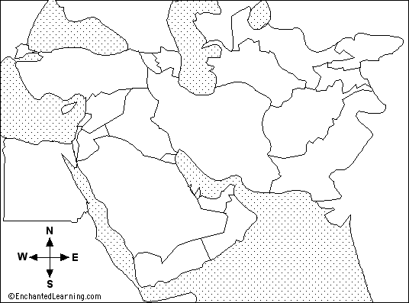
Arabian Sea
Persian Gulf
Strait of Hormuz
Suez Canal
Iraq
Gaza Strip
Israel
Afghanistan
Saudi Arabia
Iran

