India Unit Test | Study Guide – DUE FRIDAY 1/31/14 (same day as the test)

Name_______________________________

Color_______________________________

Identify the following landforms on the map of India below:
Ganges River, Deccan Plateau, Indus River, Bay of Bengal, Indian Ocean, and Himalayan Mountains.
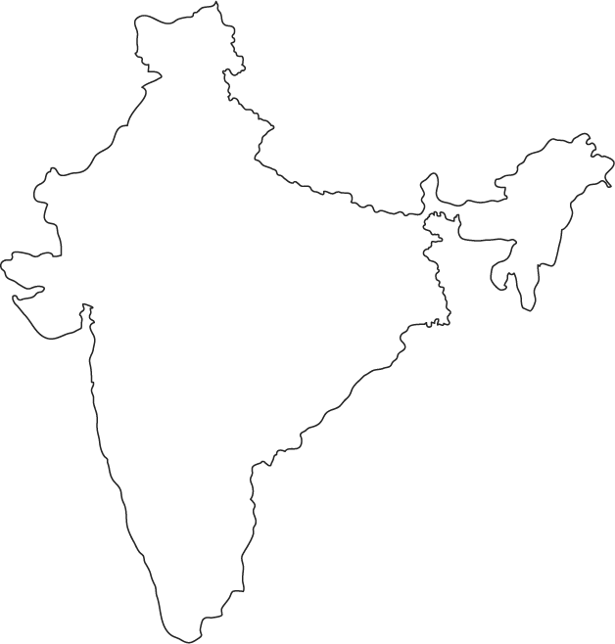

Why is the Ganges considered such an important river? How has it influenced daily life AS WELL AS religion?

Describe an environmental issue associated with the Ganges River.

Define Asian Brown Cloud and explain its cause, effect and environmental/human impact.

Define monsoon and explain its environmental/human impact.

Describe Hinduism.

What is karma? What is reincarnation?

What is the caste system? How is your caste determined?

What was the British Raj?

What was the East India Company? Why was it established? How did it impact India?

Define imperialism. How did it play a role in India’s history?

Who was Gandhi? Explain his concept of non-violence.

Define civil disobedience.

What was the reason for Gandhi’s Salt March?

What was the Rowlatt Act and its impact on native Indians?

Define nationalism. How did nationalism play a role in India’s independence?

What happened during the Amritsar Massacre? How did it play a role in India’s independence movement?

Define the Indian National Congress and Muslim League. How did religion play a role in India’s politics?

Explain the reasons for the partition of India/Pakistan.

What year did India gain its independence?

What type of government does India have?

What type of economy does India have?

Why are so many people migrating to India’s cities?

BE ABLE TO ANALYZE POLITICAL CARTOONS FOR THE TEST AS WELL

