India Unit Test | Study Guide – DUE Wednesday 2/15/17

Name_______________________________ Red Green Yellow Blue

Identify the following landforms on the map of India below:
Ganges River, Deccan Plateau, Indus River, Bay of Bengal, Indian Ocean, and Himalayan Mountains.
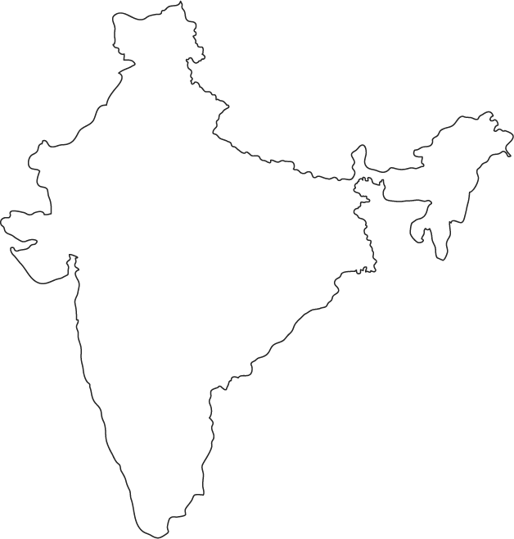

Why is the Ganges considered such an important river? How has it influenced daily life AS WELL AS religion? (CRCT Book p. 134)

Describe an environmental issue associated with the Ganges River. (CRCT Book p. 134)

Define Asian Brown Cloud and explain its cause, effect and environmental/human impact. (CRCT p. 137)

Define monsoon and explain its environmental/human impact. (CRCT p. 140)

Describe Hinduism. When was Hinduism founded? (CRCT Book p. 146)

What is karma? What is reincarnation? (CRCT Book p. 146)

Describe Buddhism. Where was Buddhism founded? (CRCT Book p. 147)

What is the caste system? How is your caste determined? (CRCT Book p. 146)

What was the British Raj?

What was the East India Company? Why was it established? How did it impact India? (British Conquest of India PPP)

Define imperialism. How did it play a role in India’s history? (British Conquest of India PPP)

Who was Gandhi? Explain his concept of non-violence. (CRCT Book pp. 187 & 193)

What did Gandhi like about the British?

Define civil disobedience. (CRCT Book pp. 187 & 193) What was the reason for Gandhi’s Salt March? (CRCT p. 193)

Give an example of civil disobedience:

What was the Rowlatt Act and its impact on native Indians? (CRCT p. 187)

Define nationalism. How did nationalism play a role in India’s independence? (CRCT p.187)

What happened during the Amritsar Massacre? How did it play a role in India’s independence movement?
(CRCT p. 193)

Define the Indian National Congress and Muslim League. How did religion play a role in India’s politics? (CRCT p. 187)

Explain the reasons for the partition of India/Pakistan. (CRCT p. 188) What year did India gain its independence? (CRCT p. 188)

What type of government does India have? Who is allowed to vote? (CRCT p. 164)

What type of economy does India have? (CRCT p. 169) What was the Green Revolution? (CRCT p.171)

Why are so many people migrating to India’s cities? (CRCT Book p. 134)

Why are urban areas in India experiencing issues with pollution? Why are rural areas having problems as well? (CRCT Book p. 137)

BE ABLE TO ANALYZE POLITICAL CARTOONS FOR THE TEST AS WELL

