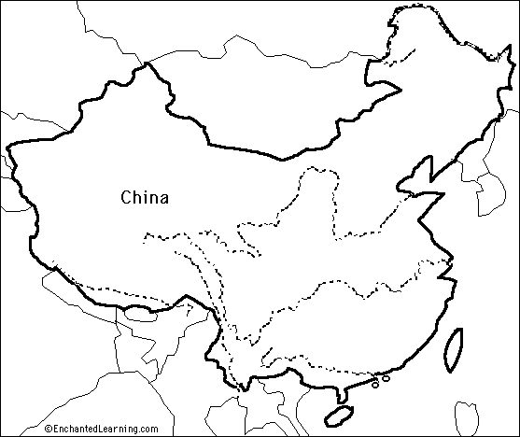

STEP 1: Identify the following physical features on the map:
- Taklimakan Dessert
- Yangtze River
- Yellow River (Huang He River)
- Gobi Desert
- Himalayan Mountains
- South China Sea
- Yellow Sea
Also identify:
- Mongolia
- Shanghai
- Beijing

STEP 2: Read the following pages in the Coach Book and answer the following questions (ONLY READ ABOUT CHINA IN EACH SECTION):

Read page 127
Why is the Huang He River also referred to as the Yellow River?

What is loess?

Why is the Huang He River (Yellow River) sometimes called “China’s Sorrow?”

Why is Shanghai an important city? Why is the Yangtze River such an important river in China?

Read p. 135
Why is the Yangtze River so important to the population and economy of China?

What are some of the environmental issues associated with the Yangtze River?

What is the Three Gorges Dam Project? Why is it significant?

Read p. 140
Describe the climate of China. Create a map key and shade in the different types of climate (on the map).

Read p. 142
What is the most common occupation in China?

What region is most heavily populated in China?

