Spring 2017| Social Studies Final Exam Study Guide
Name ___________________________________________ Green Yellow Blue Red

Describe the Sahara Desert (its features, etc.) p.11,p.26

Why is farming so difficult in the Sahel? P.25, 27-28

What is causing the Sahel to expand in recent years? P.25

What physical features might you find in the Sahel? P.25

How would you describe the rainforest? P.29-30

What is the biggest threat to African rainforests? P.29-30

What is one of the major problems facing those who depend on the Nile River for their water? P.22, 25

What do some people believe might lead to “water wars” in Africa in the future? P.22

Why do some governments ignore industrial pollution of major rivers and waterways? P.22

What is meant by the “Green Line” of desertification? P.25

What is a nomad? P.26

What religion did Arabs bring with them to Africa? P.32

What are the main religions found among the Ashanti people today? P.32

Which BEST describes the religion of the Bantu people? P.32

What religion is most common among the Swahili today? P.33

Using the chart on page 36 (coach book), which African country has the highest literacy rates?

Using the chart on page 36 (coach book), which African country has the highest GDP?

Using the chart on page 36 (coach book), how do the literacy rates for men and women compare in most of the countries represented on this chart?

In a unitary government system, who holds most of the power? P.38

Who makes most of the important governmental decisions in an oligarchy? P.39

Which branch of government is responsible for making and carrying out the laws in a parliamentary system of government? P.40

Which branch of government passes the laws in a presidential system of government? P.40

Why is the literacy rate for girls in Kenya and Sudan lower than it is for boys? P.36

Why don’t more Africans infected with HIV/ AIDS take antiretroviral drugs that can slow down the progress of the disease?p.46

Using the map on page 20 (coach book), which body of water flows north from Khartoum?

South Africa is spending money on human capital, explain why? (Coach Book p. 58)

Define Gross Domestic Product. (Coach Book p. 58 or glossary)

Describe what will happen is a country does not invest in human capital. What will happen to the GDP? (Coach Book p. 59)

South Africa is investing a lot of money in capital goods in which industry? (Coach Book p. 59)

Use the graph on p. 73 in the Coach Book to answer questions 215-217. (Q & A)

Use the chart on p. 74 in the Coach Book to answer questions 218-220. (Q & A)

Locate Egypt, Kenya, Nigeria, Democratic Republic of the Congo, Sudan and South Sudan, Nigeria, Kenya, South Africa on the map.
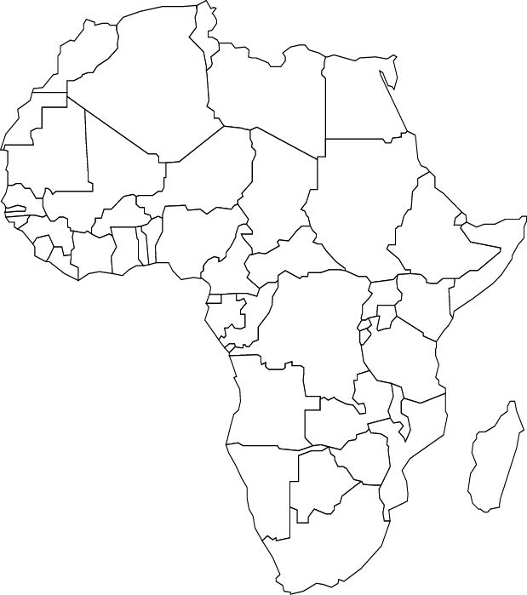
Draw in the following physical features: the Sahel, Sahara Desert, Kalahari Desert, Atlas Mountains on the map:

