Red Green Yellow Blue Name___________________________
Unit I Test Review
Define latitude. (Text p. 4) Refer to longitude & latitude worksheet to demonstrate knowledge of locating places on a world map.

Define longitude. (Text p.5) Refer to longitude & latitude worksheet to demonstrate knowledge of locating places on a world map.
Define Tropical wet climate. (Text p. 40)

Define semiarid or arid climate. (Text p. 41)

Define precipitation and list the four forms of precipitation. (Text p. 32)

Define compass rose and map key. (Text p. 10 & 11)

Define consumer, supply, and demand. (Text p. 59)

Differentiate between a plateau and a mountain. (Text p. 25)

Explain the founding of Judaism. (What Is Judaism? Note sheet and CRCT Book p. 90). Include the holy writing or text, place of worship, the Exodus, Abraham, and Moses in your explanation).

Explain the founding of Christianity. (What is Christianity? Note sheet and CRCT Book p. 91). Include the holy text, place of worship, the life/birth/death of Jesus, Roman Emperor Constantine.

Explain the founding of Islam. (What is Islam? Note sheet and CRCT Book p. 92-93). Include the holy text, place of worship, Muhammad, Gabriel, Mecca, Medina, and the Five Pillars of Islam.

Label Israel, Jordan, Syria, Iraq, Iran, Turkey, Saudi Arabia, and Afghanistan on the map below.
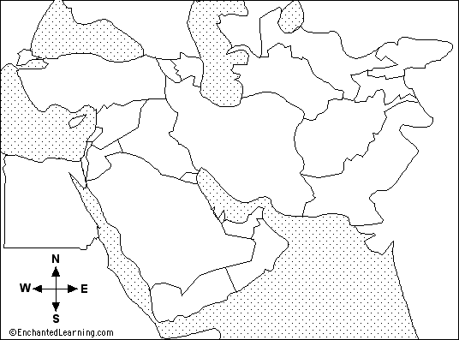

Refer to your Locating Places On a Street Map worksheet. Practice using north, south, east, and west to get to a location on the map.
Define absolute location and relative location. (Text p. 6)

Differentiate between climate and weather. (Text p. 32)

Describe environmental problems surrounding fresh water. Include climate, water scarcity, and solutions to water issues in the Middle East.

