NAME_____________________________________________________
CLASS COLOR R G Y B
Unit 1 Study Guide
In addition to this study guide, please review all notes and vocabulary

Define tropical wet climate. (Textbook p. 40)

Define semi-arid or arid climate. (Textbook p. 41)

Define precipitation and list the four forms of precipitation. (Textbook p. 32)

Define map key. (Textbook p. 10 & 11)

Explain the founding of Judaism. (What Is Judaism? Note sheet and Coach Book p. 90). Include the holy writing or text, place of worship, the Exodus, Abraham, and Moses in your explanation).

Explain the founding of Christianity. (What is Christianity? Note sheet and Coach Book p. 91). Include the holy text, place of worship, the life/birth/death of Jesus, Roman Emperor Constantine.

Explain the founding of Islam. (What is Islam? Note sheet and Coach Book p. 92-93). Include the holy text, place of worship, Muhammad, Gabriel, Mecca, Medina, and the Five Pillars of Islam.

Label the following countries on the map: Israel, Iraq, Iran, Turkey, Saudi Arabia, and Afghanistan
Label the following physical features on the map: Tigris River, Euphrates River, Persian Gulf, Suez Canal (p. 75 of the Coach book)

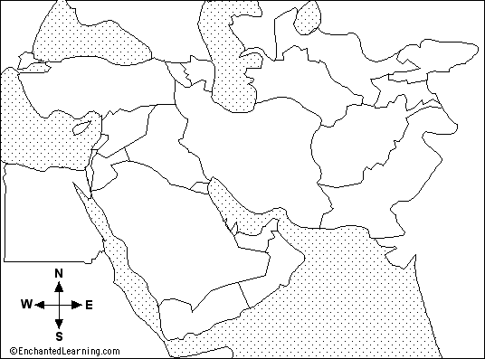

Define absolute location and relative location. (Textbook p. 6)

Give an example of each of the five themes of geography (use your notes – MR. LIP)

Explain the difference between a religious group and ethnic group (Coach Book p.88 or notes) Give an example of each.

Explain the difference between Sunni and Shia Muslims. (Coach book p.88)

Explain the difference between a monotheistic religion and polytheistic religion. Give an example of a monotheistic religion.

Describe environmental problems surrounding fresh water. Include climate, water scarcity, and solutions to water issues in the Middle East. (Notes and Coach book p. 82)

Briefly describe the following ethnic groups (Notes)
- Arabs
- Persians
- Kurds

Be able to answer general questions about The Breadwinner

