Unit 2 Study Guide
DUE Friday 11/21 (same day as test)
Review ALL notes, handouts and
Vocabulary (Voc7-11) for religion, government, economics, OPEC and M.E. Wars

Geography Review:
Identify the following countries on the map:
- Israel
- Turkey
- Saudi Arabia
- Iran
- Iraq

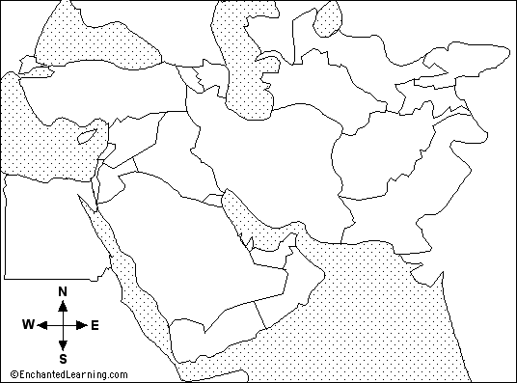

Where is the region of Palestine located?

Identify the West Bank and Gaza Strip on the map below:

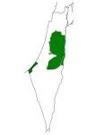
Religion:
Define:
- Monotheism

- Polytheism

Answer:
Are Judaism, Christianity and Islam monotheistic or polytheistic? What is the relationship between Judaism, Christianity and Islam? (Hint: Consider their holy books)

Government
Define the following government terms:

- Autocracy

- Republic

- Monarchy

- Theocracy

- Oligarchy

Answer:
What types of government do Israel, Saudi Arabia and Iran have? What is the legislature in Israel called?

Define Sovereignty:
Identify the four characteristics of a sovereign state:
1.
2.
3.
4.
Identify the four roles of government
1.
2.
3.
4.
Economics
Explain how trade, specialization and interdependence relate to each other?

What is the relationship between interdependence and globalization?

What is the relationship between literacy rates, human capital and GDP?

What type of economies do Israel, Saudi Arabia and Iran have?

What is human capital?

What is an entrepreneur?

OPEC
What is the primary purpose of OPEC?

Why did OPEC place an oil embargo on the United States in 1973? How does this tie into the Arab-Israeli conflict?

M.E. Wars:
What is the primary cause of the Arab-Israeli conflict?

When and why did Israel become a state?

Who lives in the West Bank and Gaza Strip?

What was the Holocaust?

Explain the concept of Zionism.

What is the primary cause of the Persian Gulf War?

What was the primary cause of Operation Iraqi Freedom?

Who is Osama Bin Laden? What was he responsible for?

Who is Saddam Hussein? What was the US concerned he was hiding?

What is a primary source? Give an example.

What is a secondary source. Give an example.

