Red Green Yellow Blue Name___________________________
World Religion Archive
Religions to Choose From | Categories (choose 4)
Judaism  Christianity  Islam | - Fashion/attire  - Birth, wedding, and Death Ceremonies  - Dietary Codes  - Prayer  - Daily Rituals  - Key beliefs or tenants  - Leaders  - Current Events  - Symbols  - Moral Codes

Your task is to compile a world religion museum archive. The box/bag will contain artifacts which you will share and reflect on.
Artifacts
- You must have 4 artifacts to represent the religion you selected. These artifacts must be presented in different mediums. For example, you cannot have all pictures or all written artifacts. A perfect archive would be a combination of two-dimensional and three-dimensional pieces that would serve as visuals and text.
- Each artifact must include a paragraph that explains how this artifact exemplifies your category and the significance of the item to the religion. A good practice is to include as many of the 5 W’s (who, what, when, where, why, & how) into your paragraph.
Example
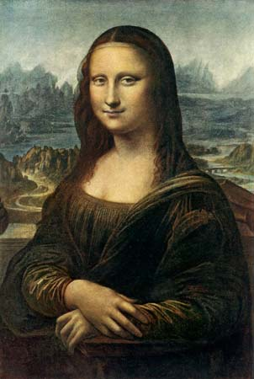
Mona Lisa, Italian painter Leonardo da Vinci is responsible for this famous painting. Historians believe he painted this between 1503 and 1506 while residing in Florence, Italy. This portrait is presently located at the Louvre in Paris, France and worth well over $1 billion. Not knowing the actual person posing for the portrait and the awkward smile sparks interest from people all around the world.
 | 4 | 3 | 2 | 1
Includes 4 relevant artifacts that pertain to the religion you chose
Each artifact includes a paragraph describing its significance to your chosen religion
Your project includes a variety of mediums (for example: a work of religious art, an excerpt from a religious text or song or a physical object)
Total Points:
Final Grade:

